Title of your Presentation (upper and lower case)
(template: “Title”)
Co-author one¹, Presenting author², Co-author two², (template: “Author”)
¹Company one + legal form
²Company two + legal form

Use of Templates
This document uses templates such that the manuscripts of all participants will look the same.
You can choose a template from the drop down menu (Templates/Formatvorlagen).
Please do not use other templates than provided.

- Template “Listing 1”
- Template “Listing 2”
- Template “Listing 3”

Note that *KEYWORDS may be written with the associated template “keyword”.

Template “Heading 1”
After using template “Heading 1”, the next paragraph will automatically change to template “Standard”

Template “Heading 2”
After using template “Heading 2”, the next paragraph will automatically change to template “Standard”

Template “Heading 3“
After using template “Heading 2” next paragraph will automatically change to template „Standard“

More templates
Template “Listing Numbers“:
- First item
- Second item
- Third item...

Figures and Tables
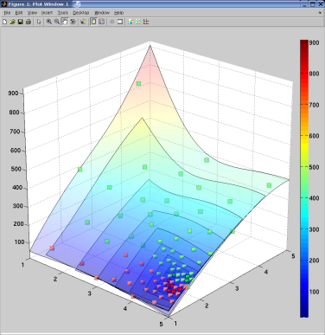
- Please use the template “Figure Caption”. The book of abstracts will be printed in grayscale.

Question of | Solution
Life, the universe & everything | 42
- If you have a table, use the template "Table Caption”.

Formulas
Please insert formulas via the word menu item "Insert" and then "Formula".

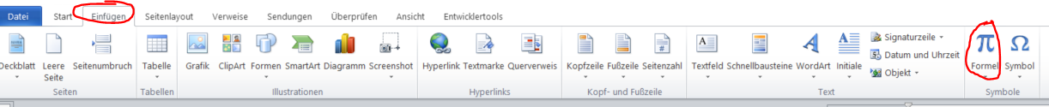

Header and footer
Please do not change the header and footer of this document.

Summary
Please write a summary of the most important results of your presentation

The European Commission has just announced an agreement whereby English will be the official language of the European Union rather than German, which was the other possibility. As part of the negotiations, Her Majesty's Government conceded that English spelling had some room for improvement and has accepted a 5-year phase-in plan that would become known as "Euro-English".
In the first year, "s" will replace the soft "c". Sertainly, this Will make sivil servants jump with joy. The hard "c" will be dropped in favour of "k".This should klear up konfusion, and keyboards kan have one less letter. There will be growing publik enthusiasm in the sekond year when the troublesome "ph" will be replaced with "f". This will make words like fotograf 20% shorter.
In the 3rd year, publik akseptanse of the new spelling kan be expekted to reach the stage where more komplikated changes are possible. Governments will enkourage the removal of double letters which have always ben a Deterent to akurate speling. Also, al wil agre that the horibl mes of the silent "e" in the languag is disgrasful and it should go away. By the 4th yer peopl wil be reseptiv to steps such as replasing "th" with "z" and "w" with "v". During ze fifz yer, ze unesesary "o" kan be dropd from vords Kontaining "ou" and after ziz fifz yer, ve vil hav a reil sensibl riten styl. Zer vil be no mor trubl or difikultis and evrivun vil find it ezi tu understand ech oza.
Ze drem of a united urop vil finali kum tru.

Literature
References should be given in the last paragraph of your manuscript. Please use following scheme:
[1] Name, Abbreviation of first name: "publication", issue, year, pages

